# Logstash PR review steps:

1. Ensure that the client_app name in the pipeline.conf is same as the folder under ../5-client-apps/
2. Make sure the cert file also matches with the same client_app name
3. Check for typos in the certificate beginning or ending.
4. In case the PR includes certificate, please validate the certificate as follows,
   1. Using UCP Bundle exec in to Logstash container,

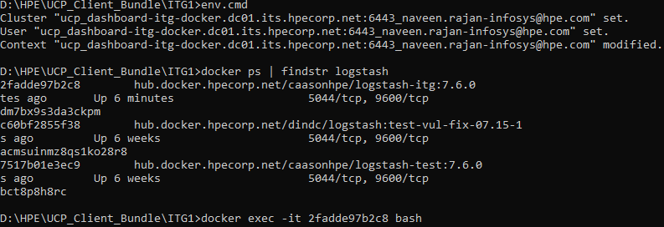

* 1. For each cert- Copy the cert from PR to the container and run

keytool -importcert -file /tmp/test.crt -keystore “config/logstash_itg_keystore.jks" -storepass "Containers529" -alias "test.crt" -noprompt – It should result in Certificate was added to keystore.

* + 1. If it throws any error, please let the user know about this error and request them to check if the certificate has any issues.

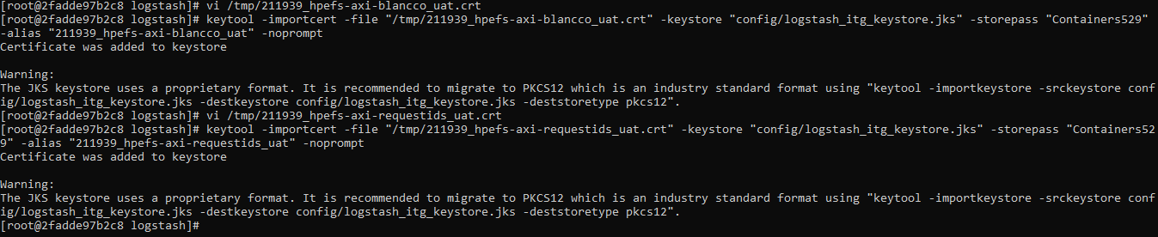

1. In case the PR includes pipeline configuration, please validate the configuration as follows,

Reference - <https://logz.io/blog/debug-logstash/>

1. Login to the Logstash container as mentioned above.
2. For each pipeline.conf - Copy the configuration from PR to the container and run -

bin/logstash --config.test_and_exit -f <path to conf file>

1. It should result in - *Configuration OK [INFO ] 2019-03-06 19:01:46.286 [LogStash::Runner] runner - Using config.test_and_exit mode. Config Validation Result: OK. Exiting Logstash*



Ii. If it throws an error, please let the user know about this and request them to fix.



If everything looks fine and Jenkins PR check passes, please merge the PR.

## Post Merge:

1. Go to logstash service settings in UCP UI and remove @sha.. till end from image name. Click save. This will restart logstash service and it will pick up the latest sha from the Jenkins build.